Final Report

## Team Members

Nicholas Aksamit (Team Leader)

na16dg@brocku.ca

6177000

Michael Missana

mm15pv@brocku.ca

6001663

Karanjot Pabla

kp16km@brocku.ca

6231377

Pranjelly Kathuria

pk17jl@brocku.ca

6333736

Fahad Ansar

fa16np@brocku.ca

6203384

Shivam Garg/Tyger Mascarenhus

sg19ga@brocku.ca

6849020

Paramvir Singh

ps17cw@brocku.ca

6366777

## Table of Contents

|  |  |
| --- | --- |
| SPRINT 1 | 2 |
| UI MEETING | 3 |
| SPRINT 2 | 3 |
| SPRINT 3 | 5 |
| SPRINT 4 | 6 |
| SPRINT 5 | 7 |
| SPRINT 6 | 8 |
| SPRINT 7 | 9 |
| SPRINT 8 | 9 |
| SPRINT 9 | 9 |
| SPRINT 10 | 10 |
| SPRINT 11 | 10 |
| Product Backlog | 11 |
| Exploratory Testing | 13 |
| Demonstrations | 14-22 |
| Full Item Screen | 14 |
| Digital Menu | 16 |
| QR Scanning Screen | 17 |
| Push Notification | 18 |
| Full Review Screen | 19 |
| UI Design and Colour Scheme | 20 |
| Database Model | 21 |
| Application Component Diagram | 22 |
| Application State Diagram | 22 |
| AR Demo | 22 |
| Google Play Application | 23 |
| Blog | 23 |
| Trello | 23 |
| Github | 23 |

## **SPRINT 1 (2/9/2021 - 2/16/2021):**

As the first sprint, the main focus was to become familiarized with react native, and to get the development portion started. Both the database and codebase were initialized, and preliminary work was completed on various required features, such as AR, camera, QR codes, and models. Additionally, a meeting was held on Feb. 11th to discuss UI design alterations. More discussion on this can be found below in section UI MEETING.

Assigned items:

* Database initialization
* Codebase initialization
* Initial AR work
* Initial camera work
* Initial QR codes work
* Initial models work
* Research on resources for 3D models
* Global stylesheet initialized
* Update README with information for process and workflow
* Finalize UI Designs
* Fahad Ansar
  + QR code generation resources were found which will be used to generate QR codes of food items.
  + Global stylesheet file for the whole app was created with some initial styles.
  + Initial AR work was done i.e. AR resources were found to be used in the app.

*(with Michael Missana)*

* + UI Finalization was done i.e. overall flow of UI and placement of components on screens. *(with Michael Miassana and Pranjelly Kathuria)*
* Nicholas Aksamit
  + Database initialization created the initial database which is hosted on DigitalOcean.
  + Codebase initialization created the initial codebase, which was react-native with expo support by default.
* Michael Missana
  + Initial AR work was done i.e. AR resources were found to be used in the app.

*(with Fahad Ansar)*

* + UI Finalization was done i.e. overall flow of UI and placement of components on screens. *(with Fahad Ansar and Pranjelly Kathuria)*
  + Third Party Component Package looking for a component package that fits with our overall theme for the app that has good resources and documentation to use as a starting point *(with Karanjot Pabla)*
* Karanjot Pabla
  + View AR Model From the Digital Menu initial work was started; outlining the menu structure, and exploring ideas on how exactly the AR Model could be shown from the menu.

*(with Paramvir Singh and Pranjelly Kathuria)*

* + Third Party Component Package looking for a component package that fits with our overall theme for the app that has good resources and documentation to use as a starting point. *(with Michael Missana)*
* Tyger Mascarenhus/Shivam Garg
  + Initial files created on git, mapping user stories on trello.
  + Commentary added and exploring ideas to setup the system.
* Pranjelly Kathuria
  + Initial UI design was finalized by deciding the overall flow of control and navigation on the user interface. The placement of components on the screen was also discussed and finalized. *(with Fahad Ansar and Michale Missana)*
  + Researched and looked for potential AR templates and sources which could be used for our app. Looked up various possibilities if we could fetch AR models from open source websites.
* Paramvir Singh
  + Initial UI Design UI prototype was prepared to get an idea of where most of the elements will be placed. *(with Fahad Ansar)*
  + Color Palette with 5 colors was generated. *(with Fahad Ansar)*
  + Initial Digital Menu basic skeleton of the digital menu was created that lets customers look at all the dishes provided by the restaurant.

Retrospective:

What went well:

* No major issues, everything went smoothly for the first sprint.

What are our roadblocks:

* Consider the packages that will be used and keep track of them.

**UI MEETING (2/11/2021):**

* Cut scan menu/digital menu screen
  + Use an application flow similar to Snapchat
* Upon first app launch, display login screen but allow user to continue without
  + If not first launch then go straight to camera
* Side menu options
  + Profile Name
  + Digital menu
  + Sign in/My Profile
  + Privacy
  + About Us

**SPRINT 2 (2/16/2021 - 2/23/2021):**

The main focus of sprint 2 focuses on three core functionalities of the application:

* Storing and retrieving 3D models
* AR implementation (camera and displaying models)
* 3D model container for item view

This sprint does not enforce the need for these features to be polished and/or fully complete, but only to have the essential framework finished. Team members should be wary of any roadblocks that may occur in the future, so sprints can be planned with less risk.

Groups are responsible for working in Trello to track and better manage large items. It may be advised to break items down into manageable pieces or to checklists.

* Fahad Ansar
  + AR resources trial run was done to select the most appropriate option. Tried Expo AR and ARCore, Expo AR was not feasible enough and ARCore has deprecation errors so discarded both options.

*(with Michael Missana)*

* Michael Missana
  + AR resources trial run was done to select the most appropriate option. Tried Expo AR and ViroAR. ViroAR demo was created in a private repo and video attached to the user story. Utilized models from Google Poly and was able to display multiple models on distinct QR codes. *(with Fahad Ansar)*
  + Created group Moqup account for continued UI work.
  + Created a workflow process and added to the Readme.
* Nicholas Aksamit
  + Database work done and tables were created following what will be needed.
  + Initial REST API created so application can communicate with database.
* Tyger Mascarenhus/Shivam Garg
  + Google poly experimentation.
  + Continued back-end work.
* Pranjelly Kathuria
  + View AR Model From the Digital Menu continued progress on menu setup; restructuring menu based upon suggestions for menu setup, and debated the feasibility of using certain AR Model platforms from the menu (confusion on Expo AR, and exploring ViroAR).

*(with Paramvir Singh and Karanjot Pabla)*

* Karanjot Pabla
  + View AR Model From the Digital Menu continued progress on menu setup; restructuring menu based upon suggestions for menu setup, and debated the feasibility of using certain AR Model platforms from the menu (confusion on Expo AR, and exploring ViroAR).

*(with Paramvir Singh and Pranjelly Kathuria)*

* Paramvir Singh
  + Rating System prototype for rating mechanism created to be used wherever required.
  + Item Screen structure for item screen was creasting, that includes view for AR, item description, tiem rating and comments left by users.

Retrospective:

What went well:

* A working prototype of displaying 3D models on QR codes

What could have went better:

* Better use of daily standup posts on Teams
* Updating Trello cards as needed

What are our roadblocks:

* Potential trouble with MySQL
* Google Poly used with ARCore/Expo not feasible

Suggestions for next sprint:

* Research more information on Viro
* Ensure communication is good between working groups

**SPRINT 3 (2/23/2021 - 3/2/2021):**

Assigned items:

* UI colour palette and styling
* Continue database work
* Look into Viro further
  + Can we add packages to the current project or must we create a new repo?
* Push notification work
* Report 1
* Continue implementing initial design
* Fahad Ansar
  + User Interface color palette and design was decided and implemented. (*with Pranjelly Kathuria)*
  + Side Menu was started for the app for useability of users. It lets you switch between the screens.
  + Push Notification feature was started which is one of the main features of the app. (*with Karanjot Pabla and Paramvir Singh)*
  + Transition to viro from expo. Tried and researched ways to transit from expo to Viro. (*with Michael Missana)*
  + Cleaning repo and shifting repo back to React Native. (*with Paramvir Singh)*
* Michael Missana
  + Continued work with ViroAR exploring integration with current expo repo.
  + Looked into the best solution for QR codes when utilizing ViroAR.
* Nicholas Aksamit
  + Database API completed for basic needs, including the fetching of database models and reviews.
* Tyger Mascarenhus/Shivam Garg
  + Working on the top navigation bar implementation.
  + Working on extended rating feature in the code.
  + Continued back end implementation.
* Karanjot Pabla
  + View AR Model From the Digital Menu continued progress on menu setup; restructuring menu based upon suggestions for menu setup, and waiting for Viro transition to be completed to allow for AR Model Display from Menu.

*(with Paramvir Singh and Pranjelly Kathuria)*

* + Push Notification feature implementation tools were explored, discovered a popular push notification library for React Native we can use, but it takes some effort to set up. (*with Fahad Ansar and Paramvir Singh)*
* Pranjelly Kathuria
  + View AR Model From the Digital Menu continued progress on menu setup; restructuring menu based upon suggestions for menu setup, and waiting for Viro transition to be completed to allow for AR Model Display from Menu.

*(with Paramvir Singh and Karanjot Pabla)*

* + Finalized the next version of the User Interface by deciding the main color palette and main theme the app is going to follow. Finalyzed the styling components and rearranged some parts of the app to make it user accessible and easy to use even for beginner level app users. *(with Fahad Ansar)*
* Paramvir Singh
  + Digital Menu Design digital menu was changed in accordance with the new UI design. Redundancy components were also removed.
  + Menu Subsection dishes belonging to the same category are put under the same subsection.
  + Search Bar functionality to search for items.

Retrospective:

What went well:

* API has models, dishes, descriptions, etc.
* UI design has colours and layouts to be implemented

What could have went better:

* Viro/Expo compatibility

What are our roadblocks:

* Viro and Expo are not working together
* Code refactor was required
* Push notification problems with Android

Suggestions for next sprint:

* User story weights/velocity
* Documentation for setup

**Sprint 4 (3/2/2021-3/9/2021):**

This sprint has a focus on the AR aspect, and integrating this functionality into the application. It will take some work considering Expo was found to not be compatible with Viro, which has superior AR capability. Push notifications will be worked on carefully to ensure multi-platform support, where previously Android had issues. Various UI elements will be developed to match the designs provided in Teams, and a basic framework for the User Registration/Login System will be implemented.

* Nicholas Aksamit
  + Login system implemented, using Facebook and Google.
  + Apple found not a feasible login method due to costs.
  + Implementation was done for Android only.
* Tyger Mascarenhus/Shivam Garg
  + Extended rating feature done
  + Continued working on the top navigation bar
  + Fixed problem regarding the nav bar and git comment added
* Michael Missana
  + Was able to get new repo working on physical iOS device
  + This introduced new Viro problems that were worked on
* Karanjot Pabla
  + Experimented the initial popular push notification library (*React Native Push Notifications*), but discovered major import issues with project
  + Tried searching and testing other push notification libraries after difficulties with the initial push notification library, but still nothing really feasible was found
* Pranjelly Kathuria
  + Researched and got familiar with the implementation of the Facebook and Google login system for the home page of the app.
* Fahad Ansar
  + Side Menu react extension was found and tried implementing which brought up few issues. Tried multiple different ways but didn't help.
  + Push Notification brought up some dependent package issues when implementing on android platform using windows. (*with Karanjot Pabla and Paramvir Singh)*
  + Transition to Viro from Expo. Made an attempt to make React viro work on windows which popped up some errors while installing it. (*with Michael Missana)*

Retrospective:

What went well:

* Running on physical iOS device
* Login with Google working; Facebook working sometimes

What could have went better:

* iOS implementation was a lot of work

What are our roadblocks:

* Viro continuing to have problems, if not fixed in next sprint will need to be re-evaluated
* Push notification problems, looking into firebase

Suggestions for next sprint:

* Front end work was slow this week

**Sprint 5 (3/9/2021-3/16/2021):**

* Nicholas Aksamit
  + Back-end API expanded for basic insertion of data into reviews
  + Had complications with using authentication at this stage
  + Facebook login system working properly
* Michael Missana
  + Continued Viro work; helped Fahad with Viro on Android
  + Helped other Developers get started with iOS
* Karanjot Pabla
  + Tried reimplementing and debugging initial popular push notification library (*React Native Push Notifications*) after the previous sprint’s struggles with other push notification libraries
  + Finally got the push notification library to work in the project, and provide push notifications on a scheduled basis
* Paramvir Singh
  + Review screen with star rating system added with breakdown of star rating.
* Pranjelly Kathuria
  + Worked on running react-native environment on Mac iOS. Looked into fixing the pod files on iOS.
* Tyger Mascarenhus/Shivam Garg
  + Continued working on the expanded rating
  + Discussion of releasing first version of the application
* Fahad Ansar
  + Side Menu: paused this to focus on other important features of the app.
  + Transition to Viro from Expo. Removed all npm packages and installed React Native and React Viro again which again popped similar kinds of errors. (*with Michael Missana)*

Retrospective:

What went well:

* Push notifications

What could have went better:

* Viro still being inconsistent

What are our roadblocks:

* Viro → transitioning into their platform completely (instead of importing their packages)

Suggestions for next sprint:

* Better communication; use of daily standups in Teams more often.

**Sprint 6 (3/16/2021-3/23/2021):**

* Nicholas Aksamit
  + Using firebase account (as is used for login on app) for authentication on back-end API
  + Checking for authentication before insertion of information works properly
  + If user does not exist, user information is first placed into database after authentication, and before review data
* Michael Missana
  + Created Viro testbed repo as a last resort if Android does not work out
  + Continued help with iOS environment setup for other devs
  + Merged current repo code into new viro testbed repo
* Karanjot Pabla
  + Further push notification code clean-up and implementation
  + Setup push notifications for support in providing required actions upon selection of notification by user
  + Fixed some stuff with iOS and Android support (both supported)
* Paramvir Singh
  + Write a comment screen added. Lets users write a review and leave a star rating. Also displays the dish in a sliding window.
* Tyger Mascarenhus/Shivam Garg
  + Worked with Paramvir Singh on the top navigation and completed it
  + Released the first version of the application to initiate downloads
* Pranjelly Kathuria
  + Looked deeper into running the react-native application on Mac iOS. Resolved the podfile issue in the previous sprint, however got stuck into runtime errors while executing the program.
* Fahad Ansar
  + Transition to Viro from Expo. Tried running an AR sample application sent by Michael. AR didn't work on my laptop and android device. I also made an attempt of creating a React Viro application after installing React Viro again but it also didn't work (*with Michael Missana)*

Retrospective:

What went well:

* Back-end API seemingly ready for use now

What could have went better:

* More work could have been completed on front-end (lots of assignments; very busy)

What are our roadblocks:

Suggestions for next sprint:

**Sprint 7 (3/23/2021-3/30/2021):**

* Push notifications were merged into main branch
* Pulling data from database for the digital menu page complete
* Expanded rating work progressed; basic styling and layout complete
* Report 2 created and progressed
* AR work progressed (still errors, but less)

**Sprint 8 (3/30/2021-4/6/2021):**

* Unused branches removed
* Blank Android application uploaded to Google Play Store
* Changed styling of application (global styles)
* Struggles with side navigation packages still
* Worked on and completed Report 2

**Sprint 9 (4/6/2021-4/13/2021):**

* Full item screen and digital menu linked (with a tap on menu item)
* YouTube implementation added (for models that have YouTube video as food display)
* Side drawer menu implemented with no errors (with dummy screens)
* Continued AR work (errors present)
* Changed end project goal for presentation
* iPhone for AR demonstration
* Android for all other application functionalities
* Presentation created

**Sprint 10 (4/13/2021-4/20/2021):**

* Merge of full item screen with digital menu functionality into main branch
* Notifications modified for notification to review in two hours after button press
* Review screen appears on app load in two hours after button press
* AR work progressed
* Presentation work continued

**Sprint 11 (4/20/2021-4/27/2021):**

* Presentation work continued and complete
* Google and Facebook authentication merged for Android
* Branch created with Viro implementation
* Android QR code scanning implemented, merged, and completed
* Submitting review functionality complete
* Back-end API functionality was slightly modified for this
* Side drawer menu discontinued
* Full login screen discontinued

## 

## 

## 

## 

## Product Backlog

|  |  |
| --- | --- |
| Using the application on Android or iOS. | *Unsure.* Android application has many issues that haven’t been resolved with regards to AR model presentation. However, many features are present on the individual OS’s without being shared between (or at least tested). |
| Viewing of product as an AR Model or YouTube video. | *65% complete.* Understanding and demo of displaying AR model complete, but is not completed yet for displaying food model. YouTube video illustration completed on product display. |
| Leaving notification some time after a user has viewed a product to review. | *100% complete*. Notifications were completed and shown to work properly through demonstration, and have been implemented in a way that will notify the user to leave a review. Application will display a button where if clicked, then the user will be asked to review after. |
| The ability to leave a like on a product that is being viewed. | *Scrapped feature.* |
| Viewing 3D Model after tapping digital menu instead of scanning QR code. | *75% complete.* Digital menu created, and back-end API to fetch menu items from database. On clicking of digital menu, the full item display appears. However, viewing of 3D model has not been completed. |
| Ability to read reviews left by previous customers. | *100% complete.* UI designed and is functional; with database connectivity. |
| Ability to leave review. | *100% complete.* UI designed and is functional; with back-end API completed to support such feature. The two are linked, and authentication properly occurs before insertion of data into database. |
| Ability to login/register. | *100% complete (for Android).* Facebook and Google authentication methods are used with assistance from the Firebase API. Our database is updated with user information if authenticated after leaving a review. |
| Notifying user after liking a product to review it. | *Scrapped feature, as liking is scrapped.* |
| Changing of the restaurant menu via application. | *Scrapped feature.* As of right now the database itself can be changed where it will be reflected on the application. |
| Viewing of startup screen on application startup. | *0% complete. Low Priority.* |
| The ability to change between light and dark themes. | *Scrapped feature.* |
| Ability to switch between screens using the side menu. | *Scrapped feature.* |

## Exploratory Testing

The testing method chosen for this agile project is exploratory testing. This procedure does not structure cases in advance, but rather completes them ‘on the fly’. It is time-efficient and verifies that crucial properties of the application are working correctly. Any issues that arise during this testing are brought up during sprint retrospective, where they are then dealt with. This may involve another project member testing the same feature, or adding it to the next sprint for additional work. If the project’s velocity drops significantly, where the amount of work progress comes to a standstill, then other testing procedures will be considered.

|  |  |  |
| --- | --- | --- |
| Number | Description | Outcome |
| 1 | Opening and closing menu multiple times through the use of the menu button and back button. Testing stability of component integration. | Pass |
| 2 | Searching feature on digital menu. Testing its unit capability. | Pass |
| 3 | Opening and closing full item menu multiple times through the use of the menu button and back button. In addition, the opening and closing of unique dishes. Testing stability of component integration. | Pass |
| 4 | Using the log in feature (Facebook and Google) on the full item screen component. Testing unit capability. | Pass |
| 5 | Submitting a new review using a Facebook and Google account on the full item screen. Testing unit capability. | Pass |
| 6 | Updating a previously submitted review on the full item screen (using Facebook and Google account). Testing unit capability. | Pass |
| 7 | Pressing “Ask me later to review” button sends notification to review two hours later. | Pass |
| 8 | After receiving notification and pressing it (with app closed), the full review screen opens. | Pass |
| 9 | After receiving notification and pressing it (with app open), the full review screen opens. | Fail |
| 10 | Scanning QR code multiple times through the use of QRCodeScanner and back button. Testing stability of component integration. | Pass |

## Demonstrations

### Full Item Screen (Left Old; Right New; Bottom Newest)

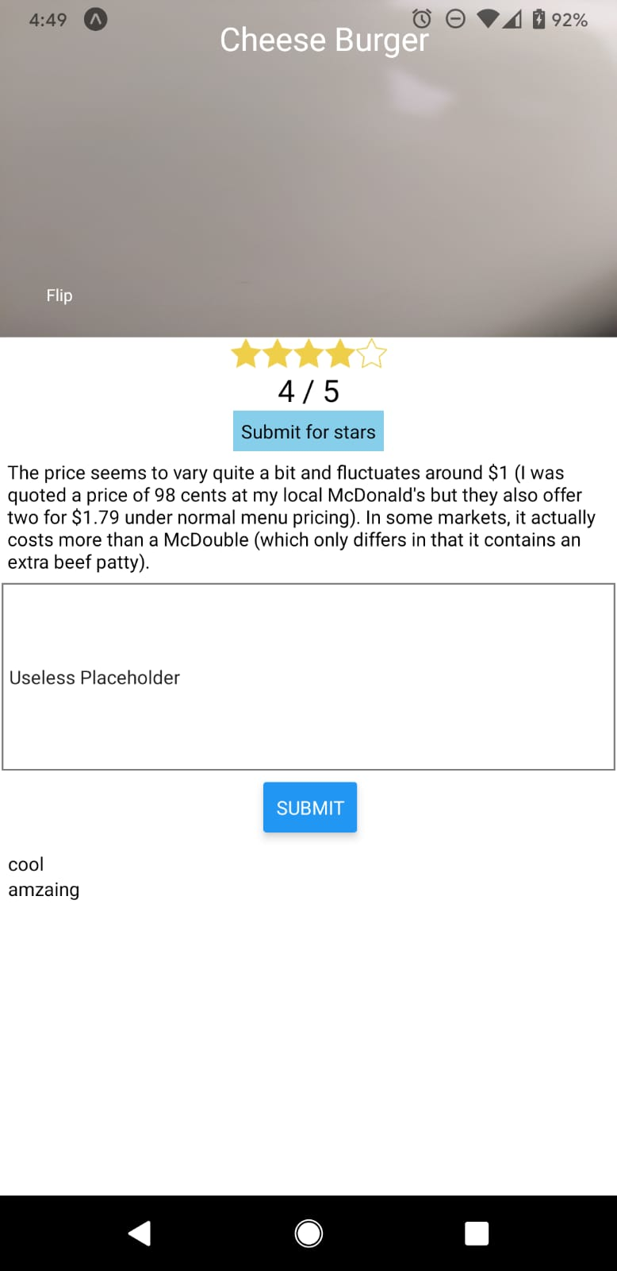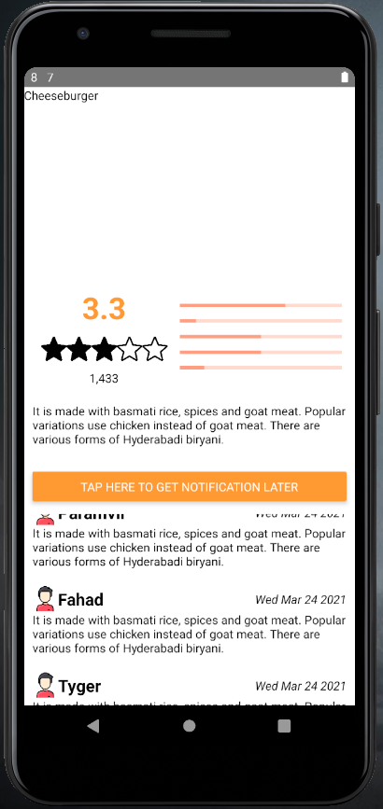



### Digital Menu

|  |  |
| --- | --- |
|  |  |

### QR Scanning Screen



### 

### Push Notification

*Note: Sending of push notification shortened for demonstration*

**

### 

### Full Review Screen



### UI Design and Colour Scheme

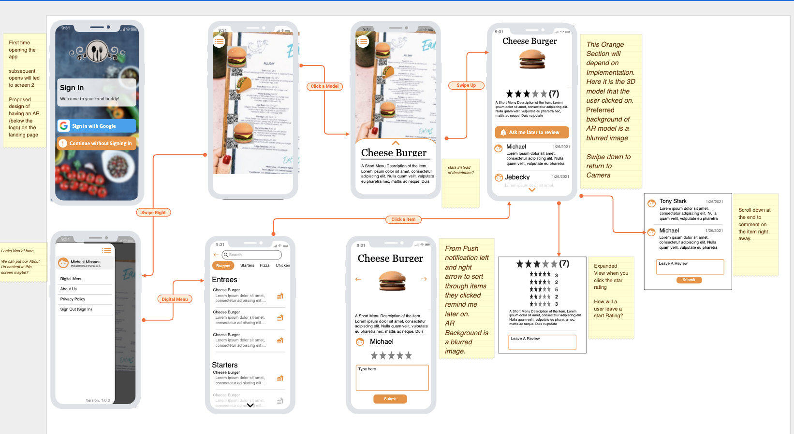

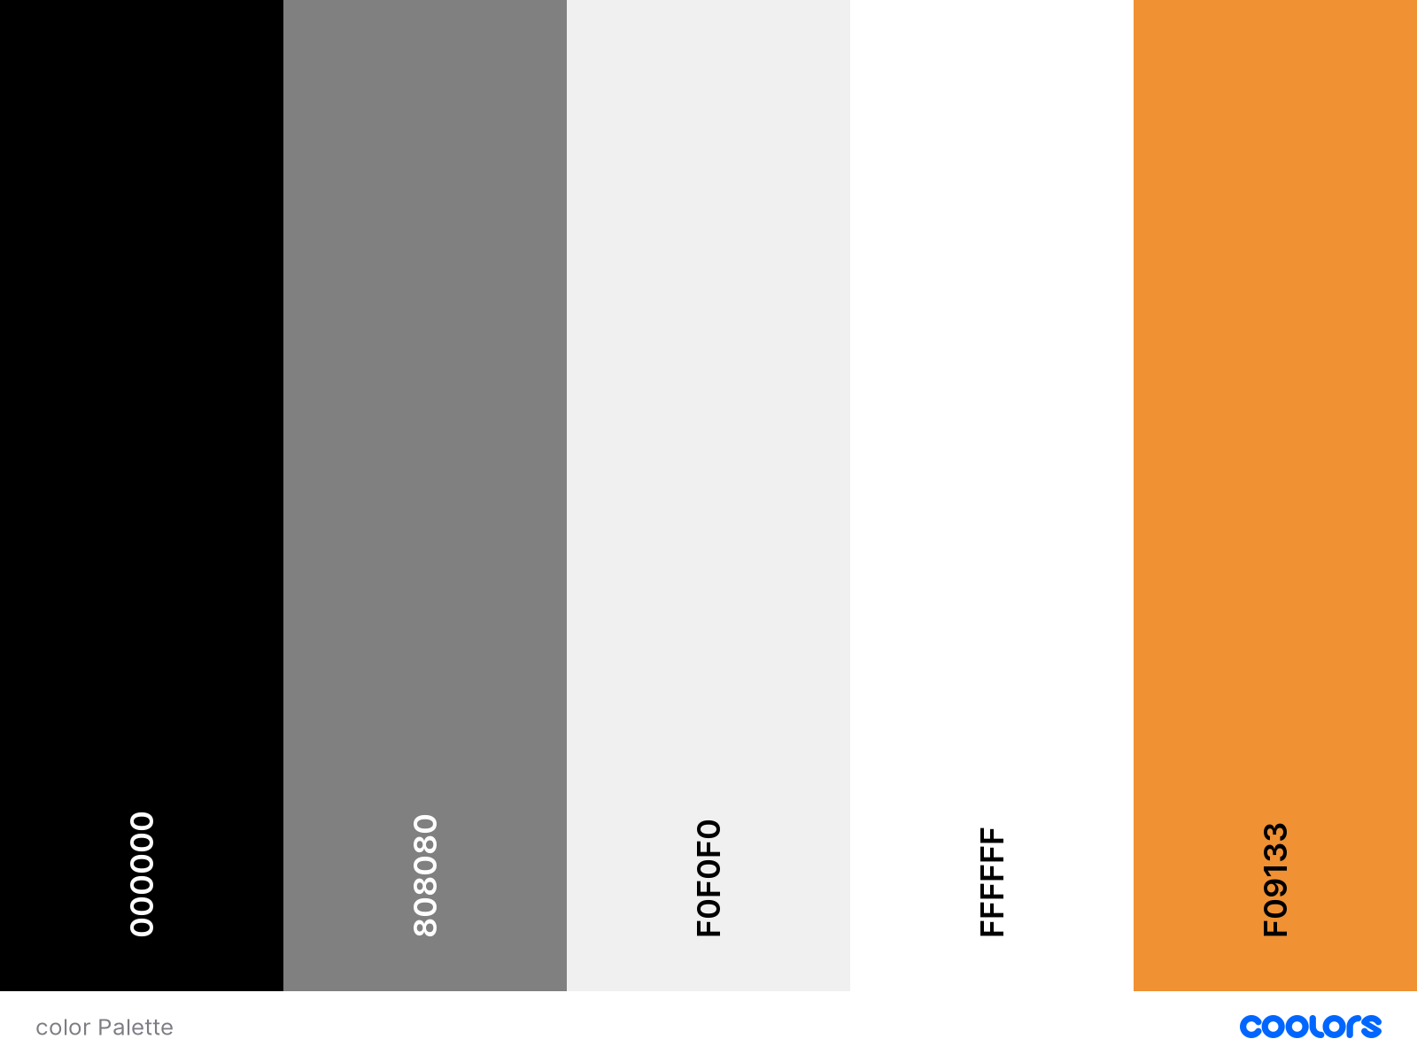

### Database Model (Top Old; Bottom New)

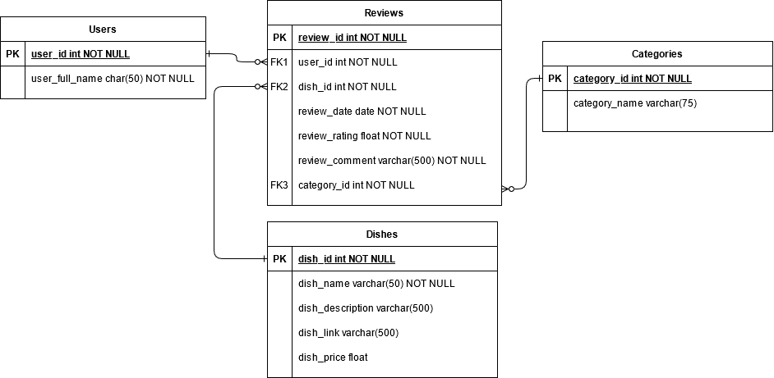

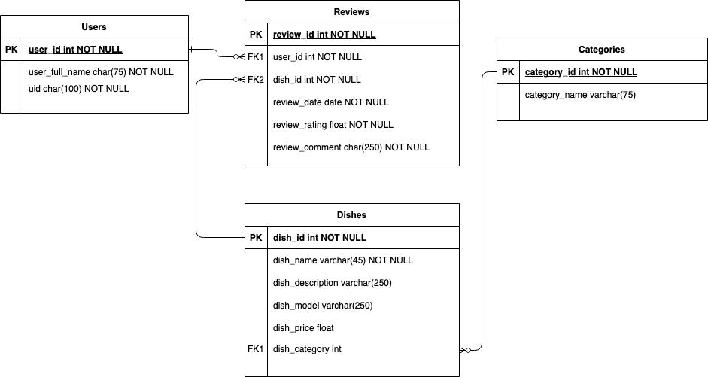

### Application Component Diagram

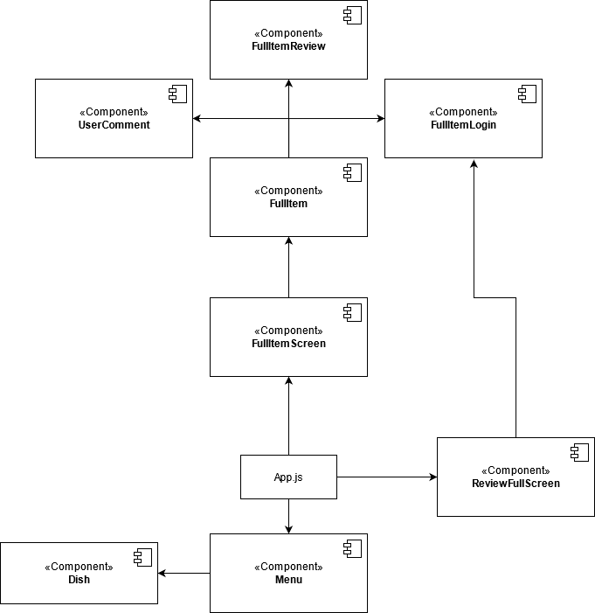

### Application State Diagram

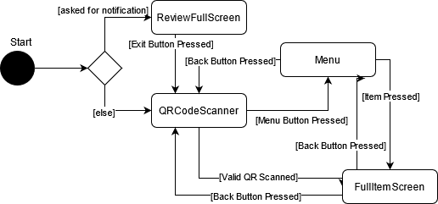

### AR Demo

[Demo Video](https://youtu.be/sFc0kvZiNgE)

### Google Play Application

[Link](https://play.google.com/store/apps/details?id=com.na16dg.restaurantar)

### Blog

[Link](https://restaurant-ar.tumblr.com/)

### Trello

The software Trello was used as a board for our user stories. It marked activities to be completed this upcoming sprint, and activities were moved to “In Progress” when being worked on. Afterwards, they would be put into the “Complete” section if complete, or shifted back to an activity that must be completed this upcoming sprint.

[Link](https://trello.com/b/WOMtlcut/user-stories)

### Github

Github was used as the repository for our code. All changes can be found here, with differences seen in between the various commits pushed. Throughout the development process, branches were created however they were swiftly removed when not needed any longer.

[Link](https://github.com/Pixelatory/RestaurantAR)